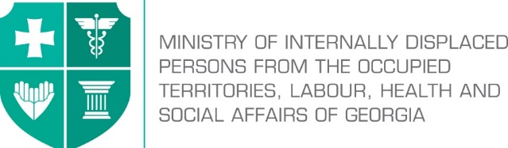

Labour Conditions Inspection Department
Create Together Safe Working Environment!

Annex №3

General Guidance Related to Infection (COVID-19) Caused by Novel Coronavirus (SARS-CoV-2) for Border Protection Staff

Note: In accordance with Order N281/N of the Minster of Internally Displaced Persons from the Occupied Territories, Labour, Health and Social Affairs of Georgia on “the rule for Examination for Short-term Employment Disability and Issuance of Doctors Note”, the Ministry of Internally Displaced Persons from the Occupied Territories, Labour, Health and Social Affairs of Georgia will issue an equivalent document to the doctors excuse note (Medical Certificate) to persons quarantined in order to prevent the spread of coronavirus. The document will serve as the basis to receive monthly payment and therefore, the working days spend in quarantine or in self-isolation will be legitimate and fully paid to the employees. In order to get the certificate, an interested person has to apply to the Ministry of Internally Displaced Persons from the Occupied Territories, Labour, Health and Social Affairs of Georgia at - info@moh.gov.ge.

The following document provides guidance for employers involved in border protection and screening operations. During the combination of different activities, the employer, based on the identification of hazards and risk assessment, must ensure engineering and administrative controls for applying safe work practices and possible use of personal protective equipment. In addition, before starting work performance, the employees’ health condition must be controlled.

The staff must not appear in the workplace if they:
- Left the affected country over the past 14 days;
- Were in close contact with infected person/persons for the past 14 days (they must be self-isolated/quarantined as per the rule);
- Have symptoms of respiratory infection (coughing, temperature, sneezing, difficulty in breathing, general weakness etc.);
- Are among the ones who have high risk of getting infected with COVID – 19 or serious complications: over 70 of age, people suffering from chronicle diseases (cardio-vascular diseases, diabetes, bronchial asthma and other respiratory diseases.

Engineering controls
Use physical transparent barriers to separate border protection officers and other workers from incoming travelers.
Use designated areas, such as dedicated, private rooms with closeable doors, to isolate travelers suspected of having COVID-19, including those with obvious or self-reported signs and/or symptoms of infection.

If workers are screening passengers for fever, use contactless (i.e., thermal sensor) thermometers to prevent workers from needing to touch sick travelers and to maximize the distance that can be kept between workers and such travelers.

To maintain the distance between travelers, use mandatory conditional signs(using stickers on the floor). In closed spaces, try to regulate the traveler flow.

Personal Protective Equipment (PPEs)
Employers in line with existing hazard and risk assessments must consider the use of PPEs (such as gloves or eye and face protection).
Border protection officers entering rooms where travelers with suspected COVID-19 have been isolated, such as during augmented (i.e., secondary, tertiary) screening steps, may need to be protected with higher level PPEs (recommended gowns and respirators FFP2, FFP3). In those cases, respirators must be used in accordance with manufacture’s guidelines.
After removing PPE, it is necessary to wash hands with soap and water, if available, or hand treatment with 70% alcohol based disinfectants.
At places allocated for donning and doffing of PPEs, place special bins for biohazard waste. The waste must be removed periodically by an appropriate person/service.

